MARQUETTE HOUSING COMMISSION

Date Established: The Marquette Housing Commission was established on June 13, 1966 when the City Commission adopted Chapter 59 of the City Code. The Housing Commission is responsible for the operation of the City's subsidized public housing and also sets policy and programs for its staff.
Corresponding MCL#, City Charter Citation, and/or City Code: MCL 125.654; Code: Chapter 16, Article II, Sec. 16-19 through Sec. 16-25.
Number of Members & Term of Office: Five members serving five-year terms.
Do members serve until a replacement is appointed? If not reappointed within five days, the seat is vacant, per MCL 125.654(b).
Quorum Requirement: Per section 13-4 of the City Charter, a quorum of any board, commission, or committee created by or pursuant to this charter shall be a majority of the members of such board, commission, or committee in office at the time, but not less than two members.
Meetings Held: The fourth Tuesday of each month at 2 p.m. in its offices at 316 Pine St.
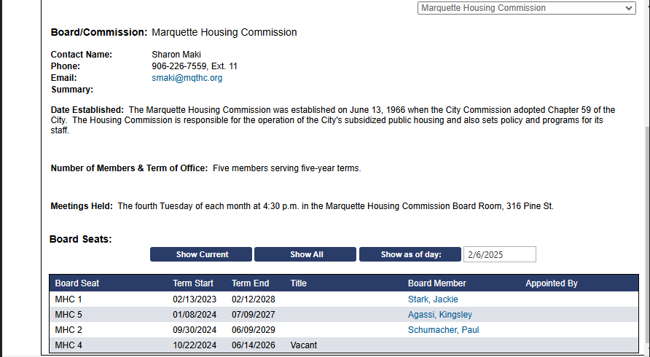
Bylaws: Yes.

Staff Liaison – Sharon Maki
Secretary designee – Susi Hurley
Updated 1/9/2024

