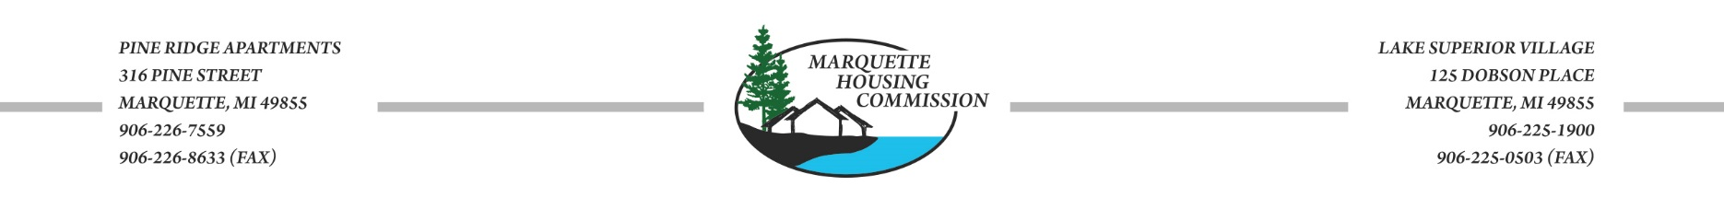

April 1, 2020
To: All Marquette Housing Commission Residents, HCV families and MHC employees
From: Sharon L. Maki, Executive Director
RE: COVID-19
Due to Executive Order 2020-21, the Pine Ridge Apartment building and all Marquette Housing Commission administrative offices will be closed to the public.
Marquette Housing Commission operations will continue, however the Housing Commission will be operating at reduced staffing levels for the duration of the Executive Order. Administrative staff will remain available via phone, text, mail or email during normal business hours. Public Housing Administrative staff will maintain business hours Monday-Friday from 10:00-2:00 to conduct required business operations and ensure the safety of tenants of the Housing Commission. Staff will be available by appointment only.
Maintenance staff will be on site at Pine Ridge Apartments Monday-Saturday from 10:00-2:00 and Lake Superior Village Monday-Friday from 10:00-2:00. They will be sanitizing high traffic areas, doing general cleaning and maintaining the grounds. In the event of a snow storm, staff will be on site and conduct normal snow removal procedures. Only emergency work orders will be completed during this time. The maintenance staff continues to be on call for all emergencies.
During this time there will be no move in of new tenants. There will also be no evictions due to inability to pay rent resulting from COVID 19.
Pine Ridge Apartments 906-226-7559
Lake Superior Village 906-225-1900

